**Design of the System**

I.) Login

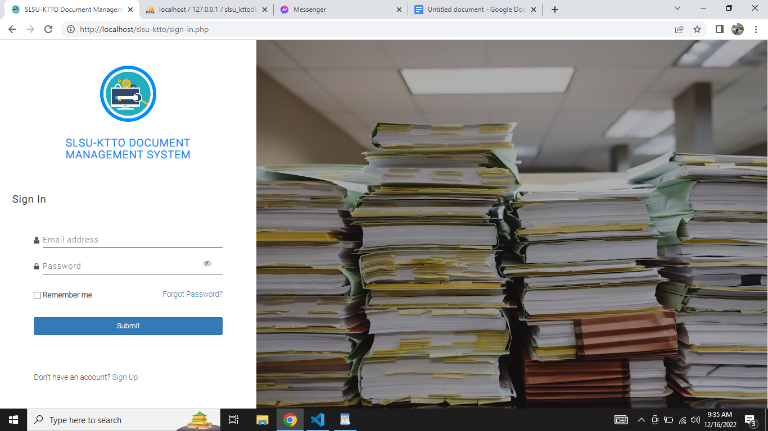

This is the part where the user is allowed to enter their credentials before they can continually access the system.

II.) Signup

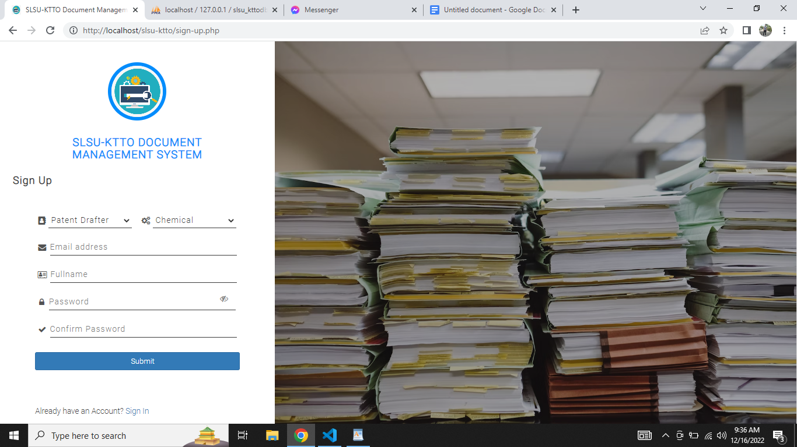

This is the part where the user created their account

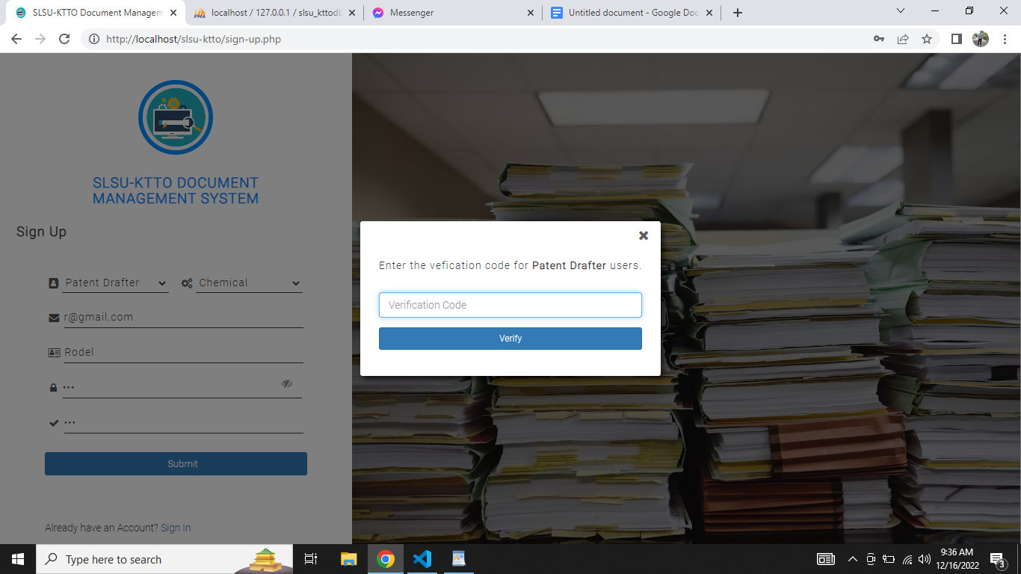

**For Patent Drafter Users**. The patent drafter user is required to enter the verification code. The code was set default as per the developer created the system.

III.) Password Recovery

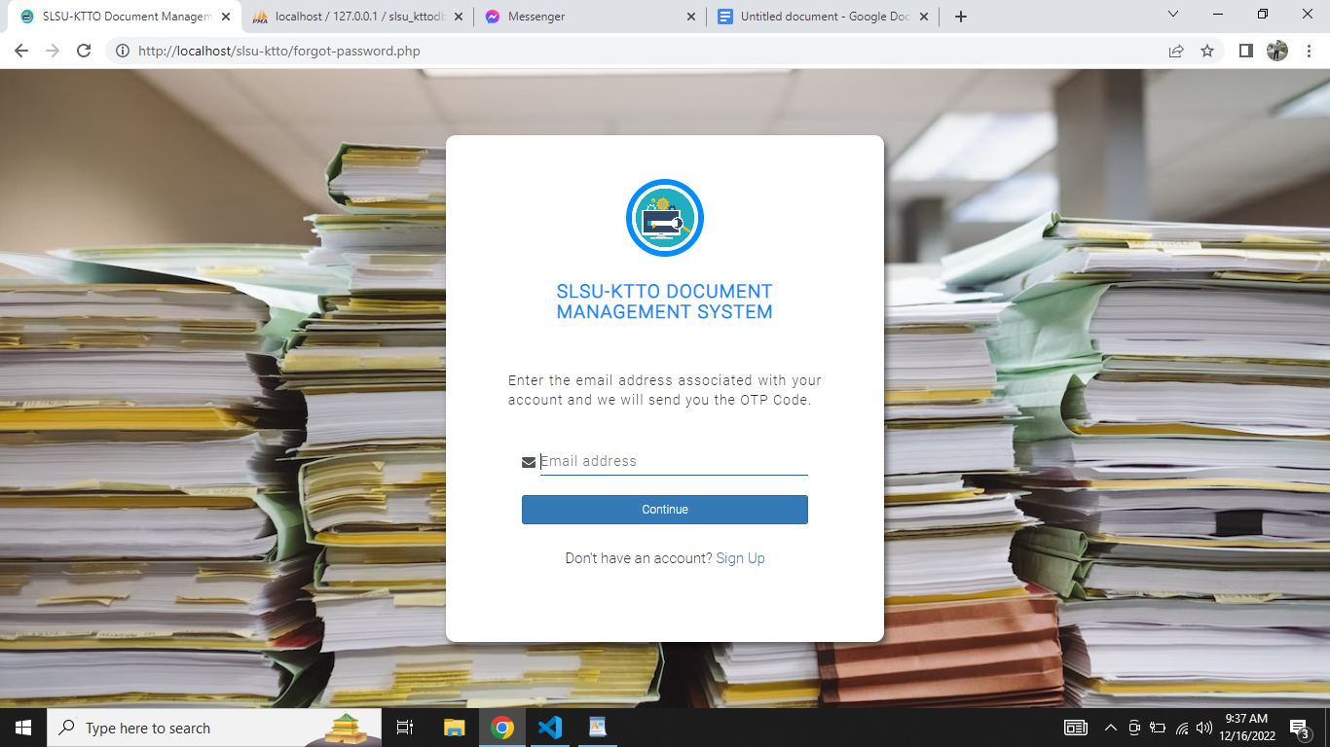

This is the part where the user enters their respective email where the system sends an OTP Code.

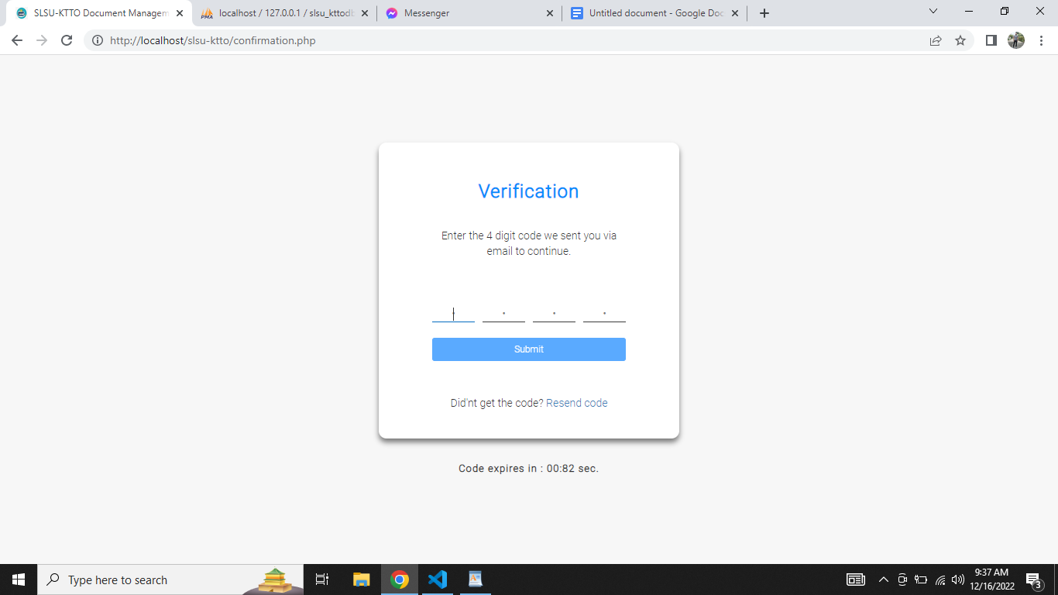

This is the part where the user is redirected after entering the email above.

IV.) Dashboard

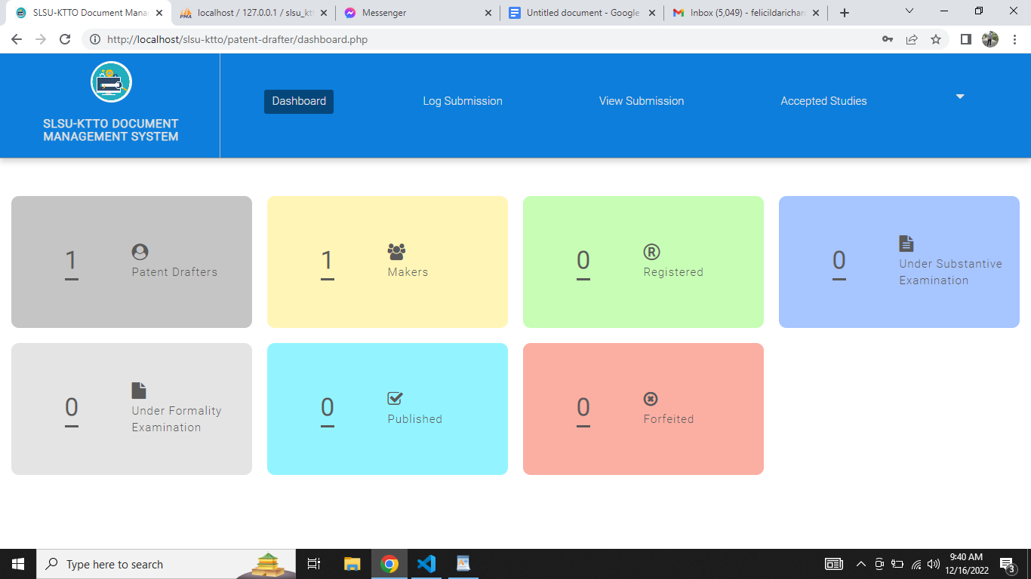

This is the dashboard of the system w/c represents the visual counts on each category.

IV.) Log Submission

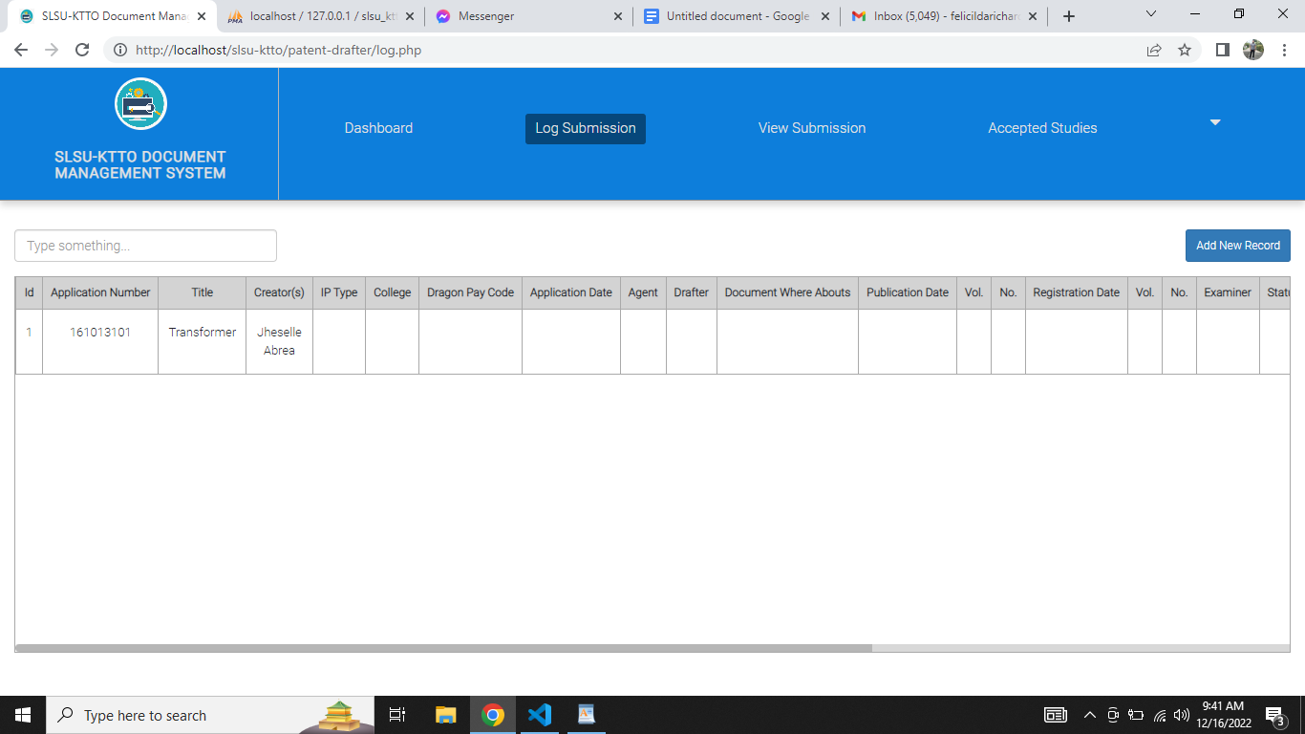

This is the part displaying the list of created log submission records.

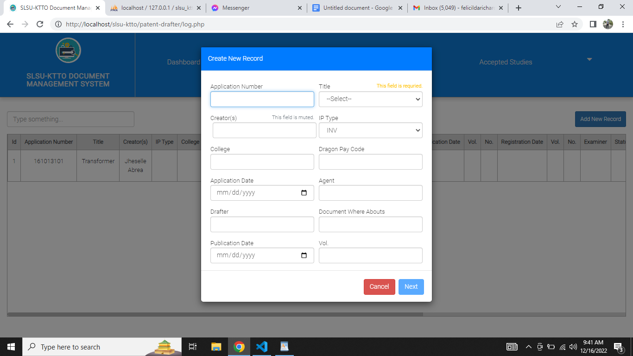

**For Patent Drafter and Director User only.** This is the part where the user created a new record for log submission.

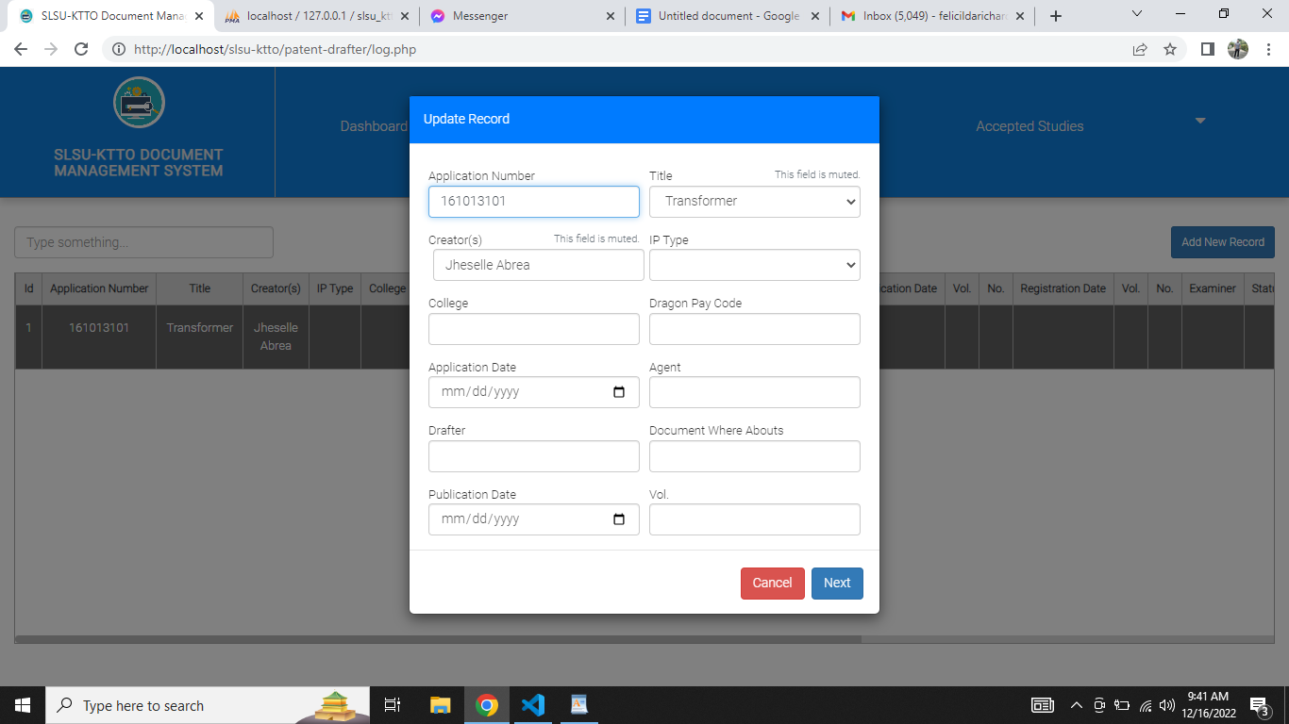

**For Patent Drafter and Director User only.** This is the part where the user selects a specific record and performs any changes on it.

IV.) View Submission

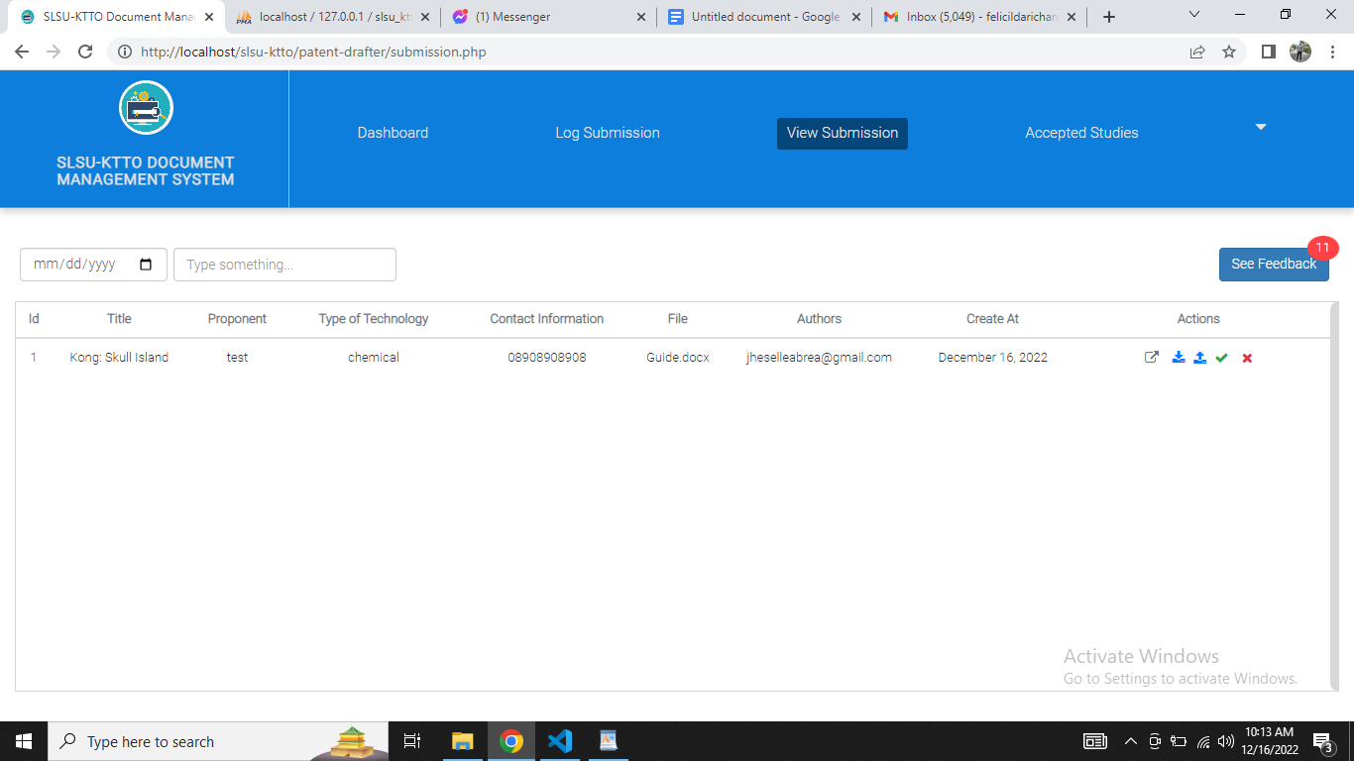

**For Patent Drafter and Director User only.** This is the part which displays the list of created study of makers.

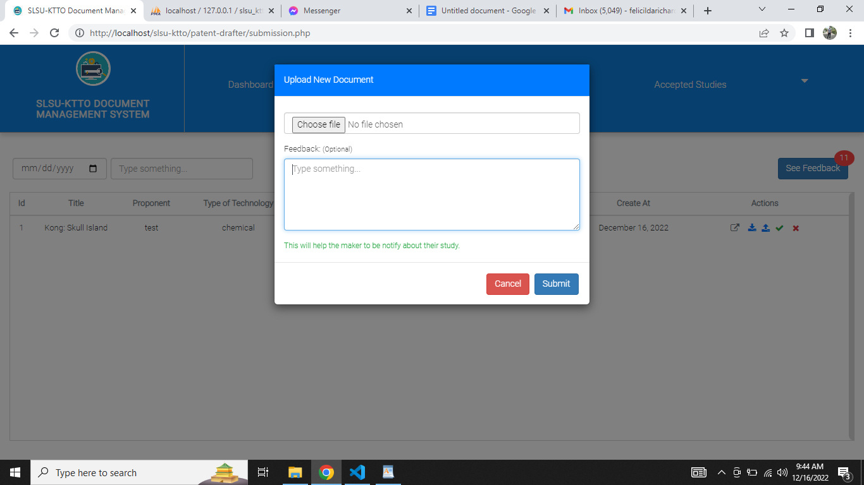

**For Patent Drafter and Director User only.** This is the part where the user was done doing patent check and wanted to update or upload a new file for the maker’s study.

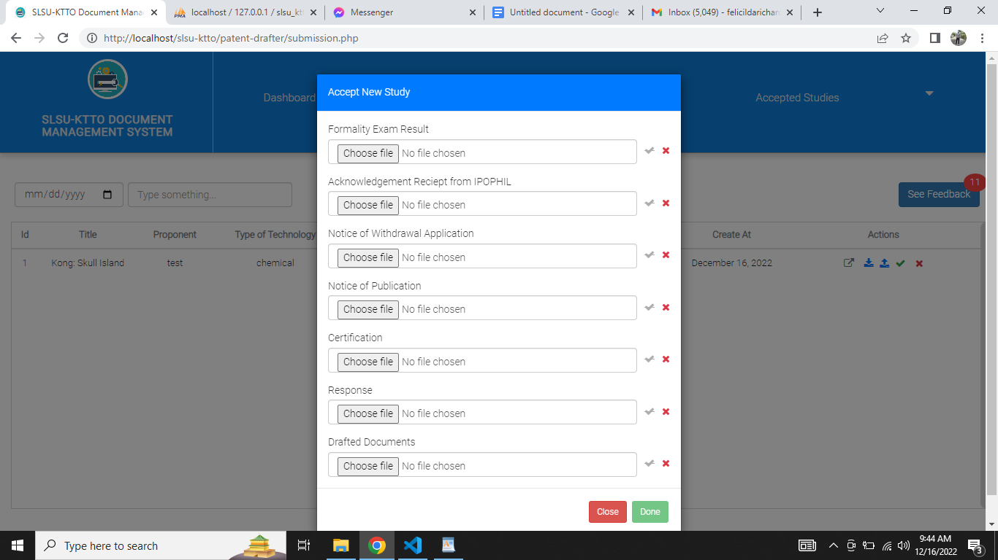

**For Patent Drafter and Director User only.** This is the part where the user was done doing patent check and ready to submit the study to IPOPHIL. The user is required to select one or many documents wanted to upload.

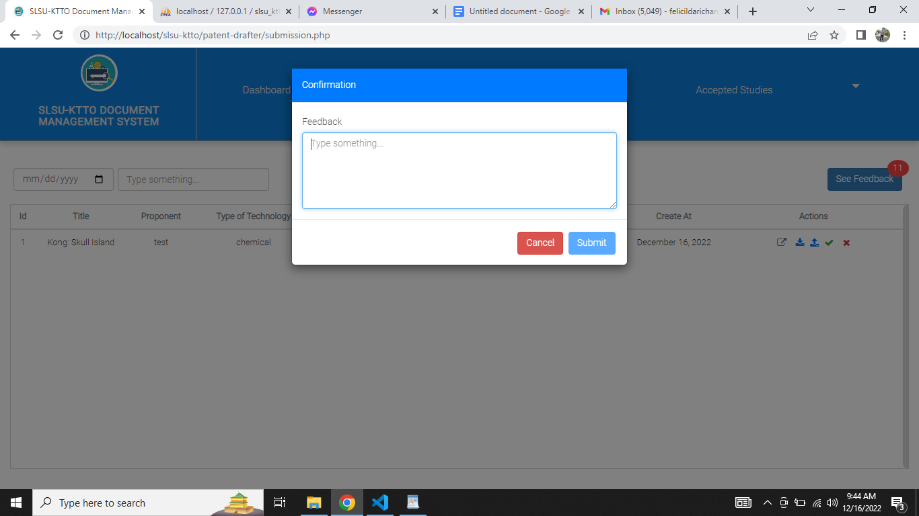

**For Patent Drafter and Director User only.** This is the part where the user was done doing patent check and is not satisfied with the submitted study.

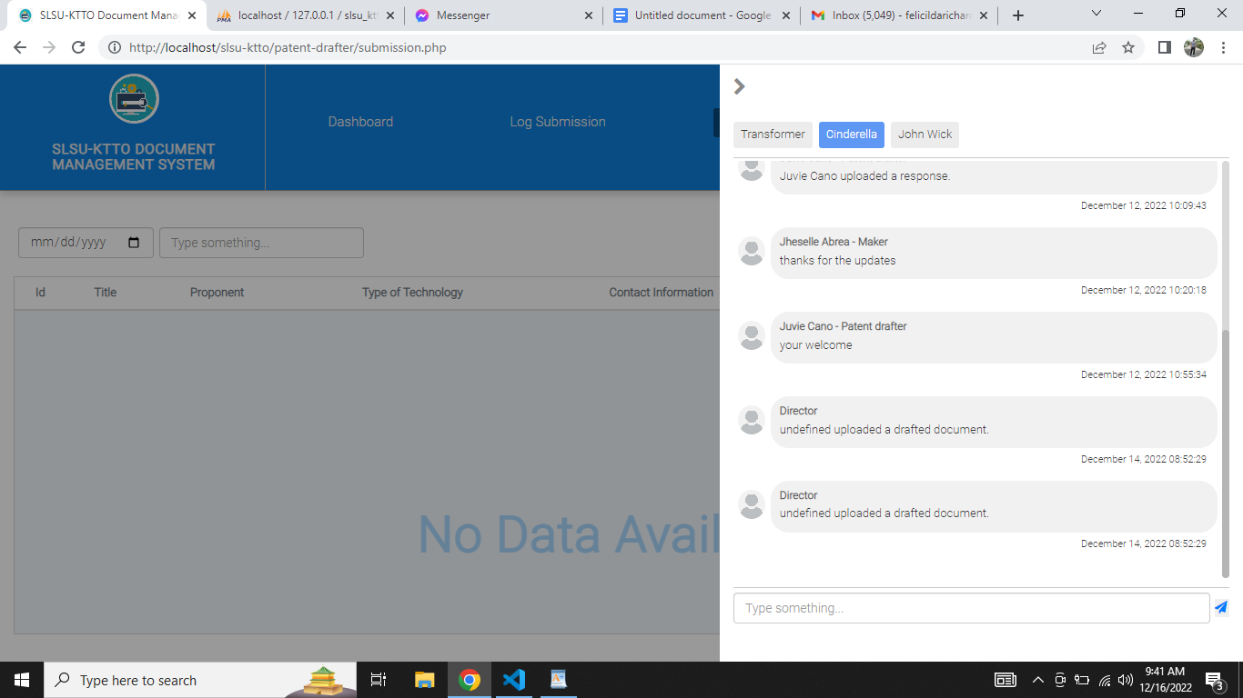

This is the part where the user hits the button “See Feedback”. It shows a side drawer that displays specific comments between the two or three users. (**Director, Makers, Patent drafters.**)

V.) Accepted Studies

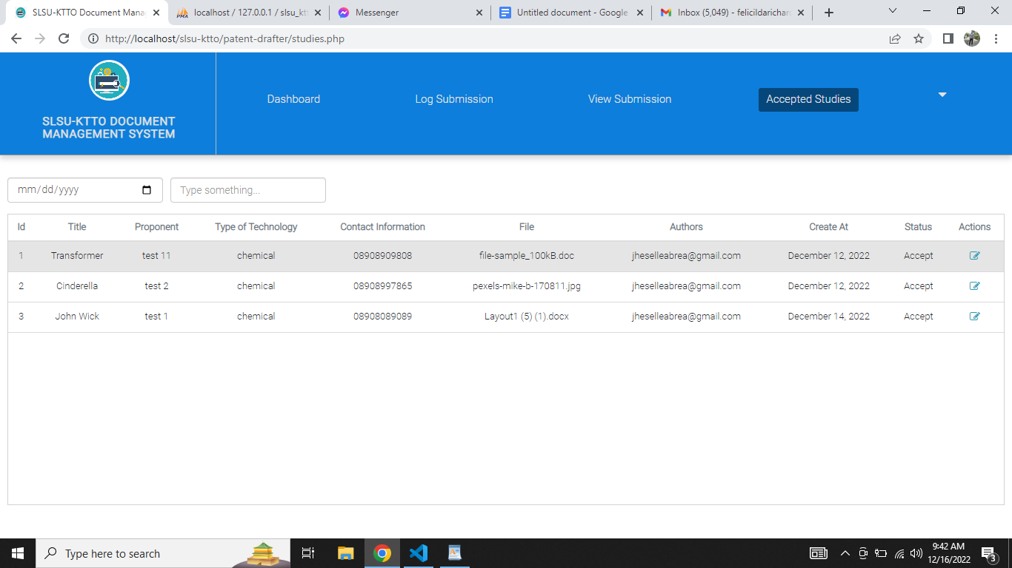

**For Patent Drafter and Director User only.** This is the part which displays the list of accepted studies.

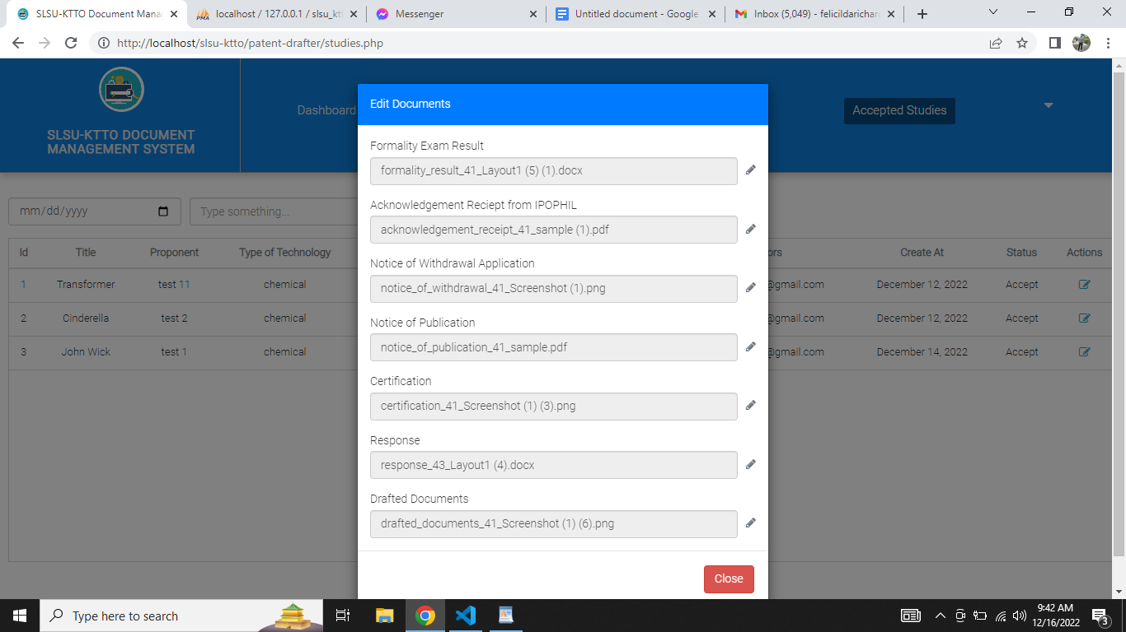

**For Patent Drafter and Director User only.** This is the part where the user wanted to update the current document uploaded for the maker.

**Maker Users**

I.) Log Submission

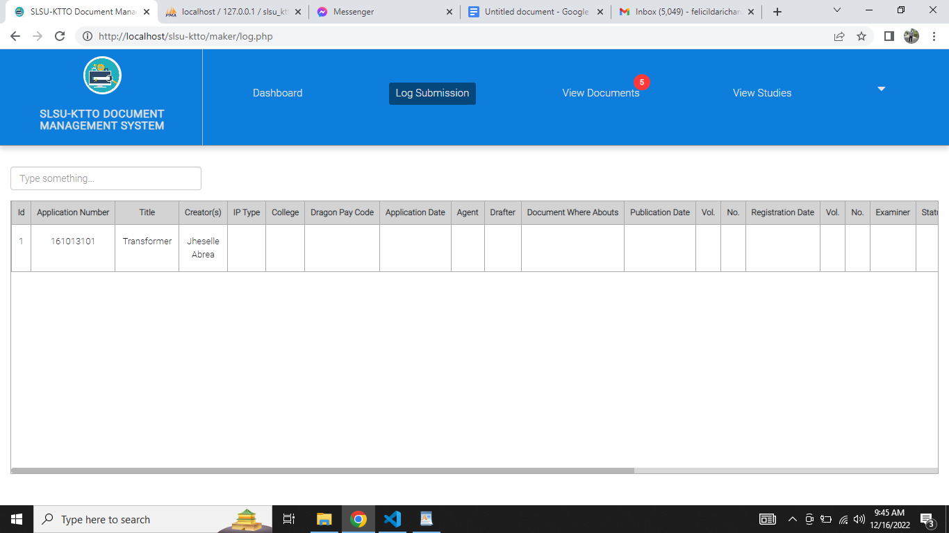

**For Makers User only.** This is the part which displays the list of current log submissions. The maker is not authorized to make any actions on this part.

II.) View Documents

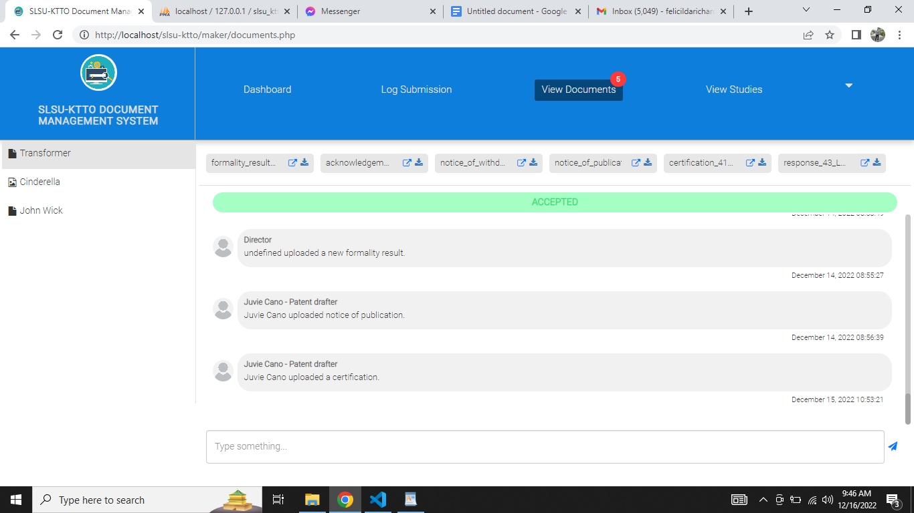

This is the part where the maker sees the list of accepted and rejected studies. Also they can also see or download the uploaded documents from the **Patent Drafters** and **Directors**. Lastly, they also reply to the comment.

II.) View Studies

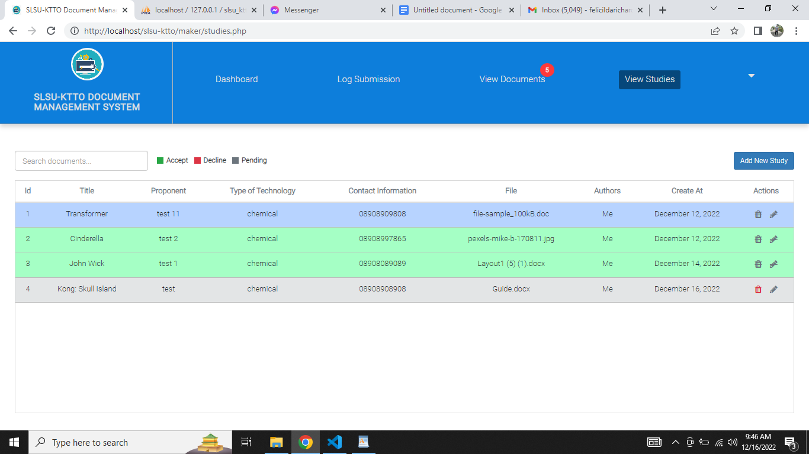

This is the part where the maker sees the list of studies.

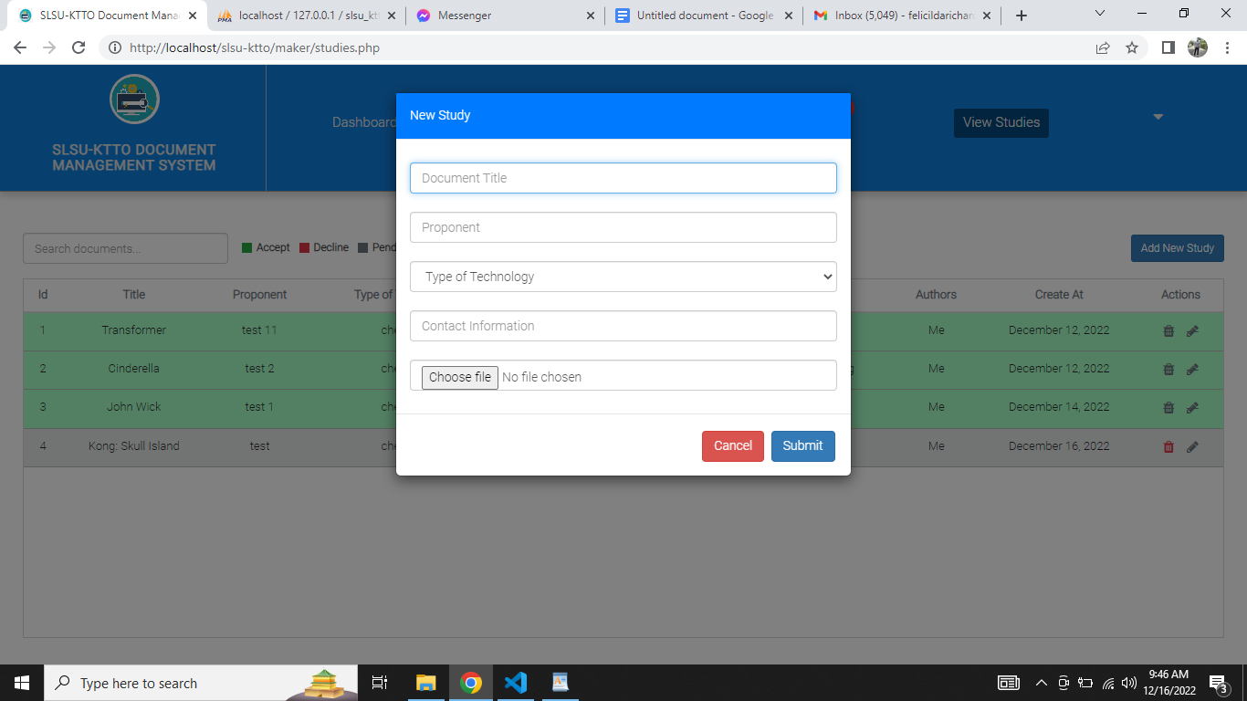

This is the part where the maker created a new study.

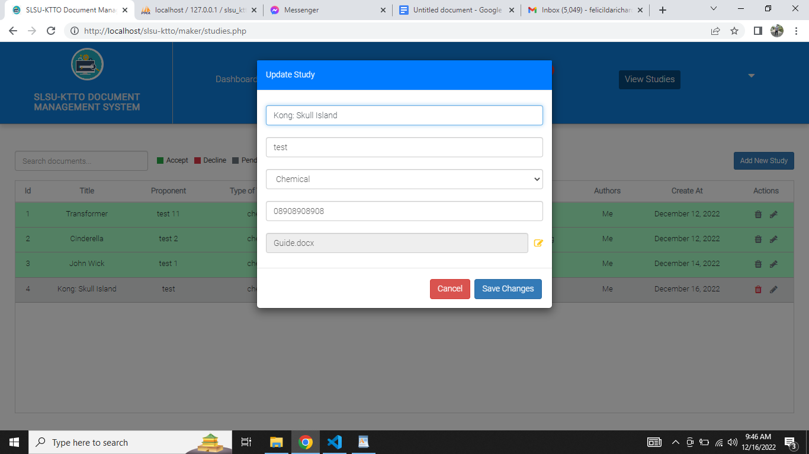

This is the part where the maker selected a specific study and wanted to perform any changes of it.

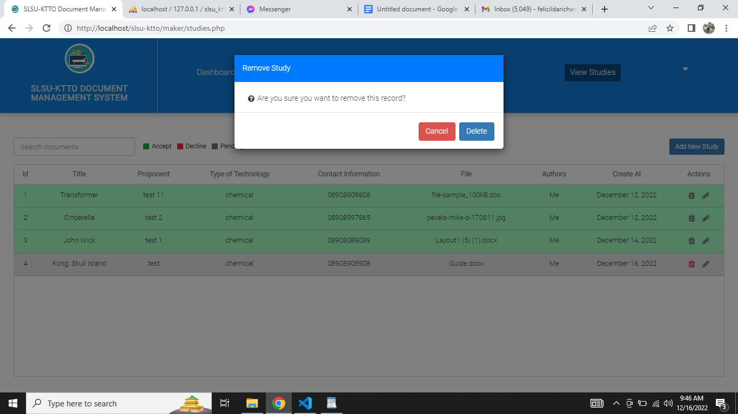

This is the part where the maker selected a specific study and wanted to remove it.

**Profile**

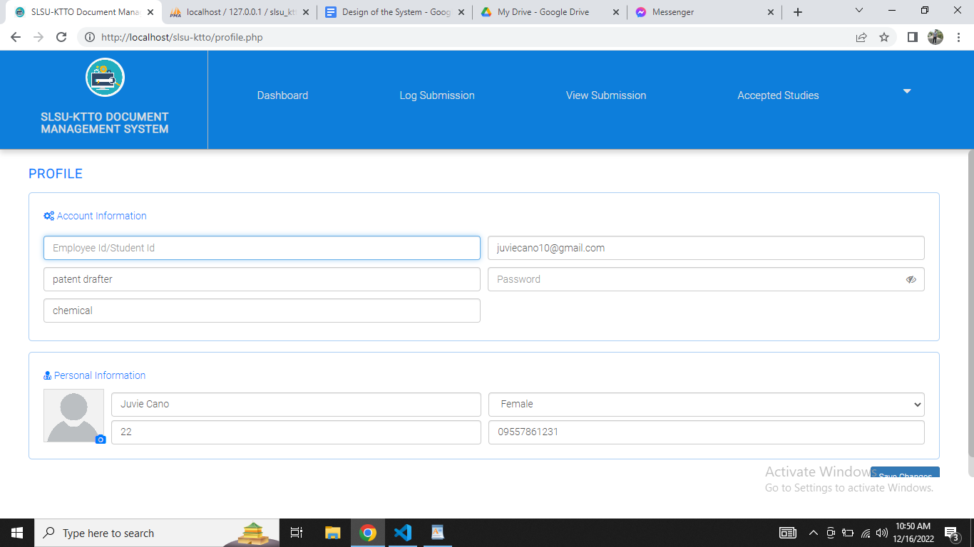

**For All Users.** This is the part where the user sees their account and personal information. They can also modify it.